Talha Khan
IT-481-DL1
4/27/2026

Assignment – Bonus Lab Assignment 2 – Working in GCP and Azure

PART 1: GCP
Task 1: Exploring the BigQuery Console
Step 1: I started by opening the BigQuery Console in the Google Cloud Console. 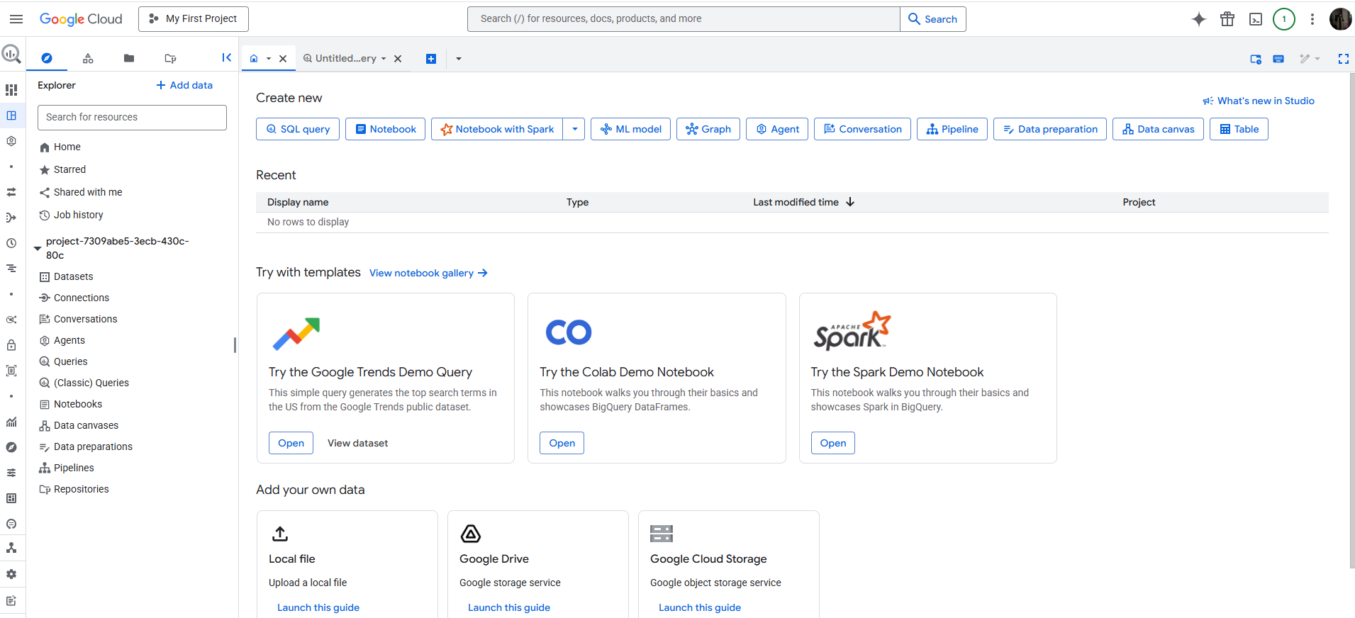
Step 2: I clicked on +ADD in the eplorer menu and choose the “Star a project by name” and named it as “bigquery-public-data”. 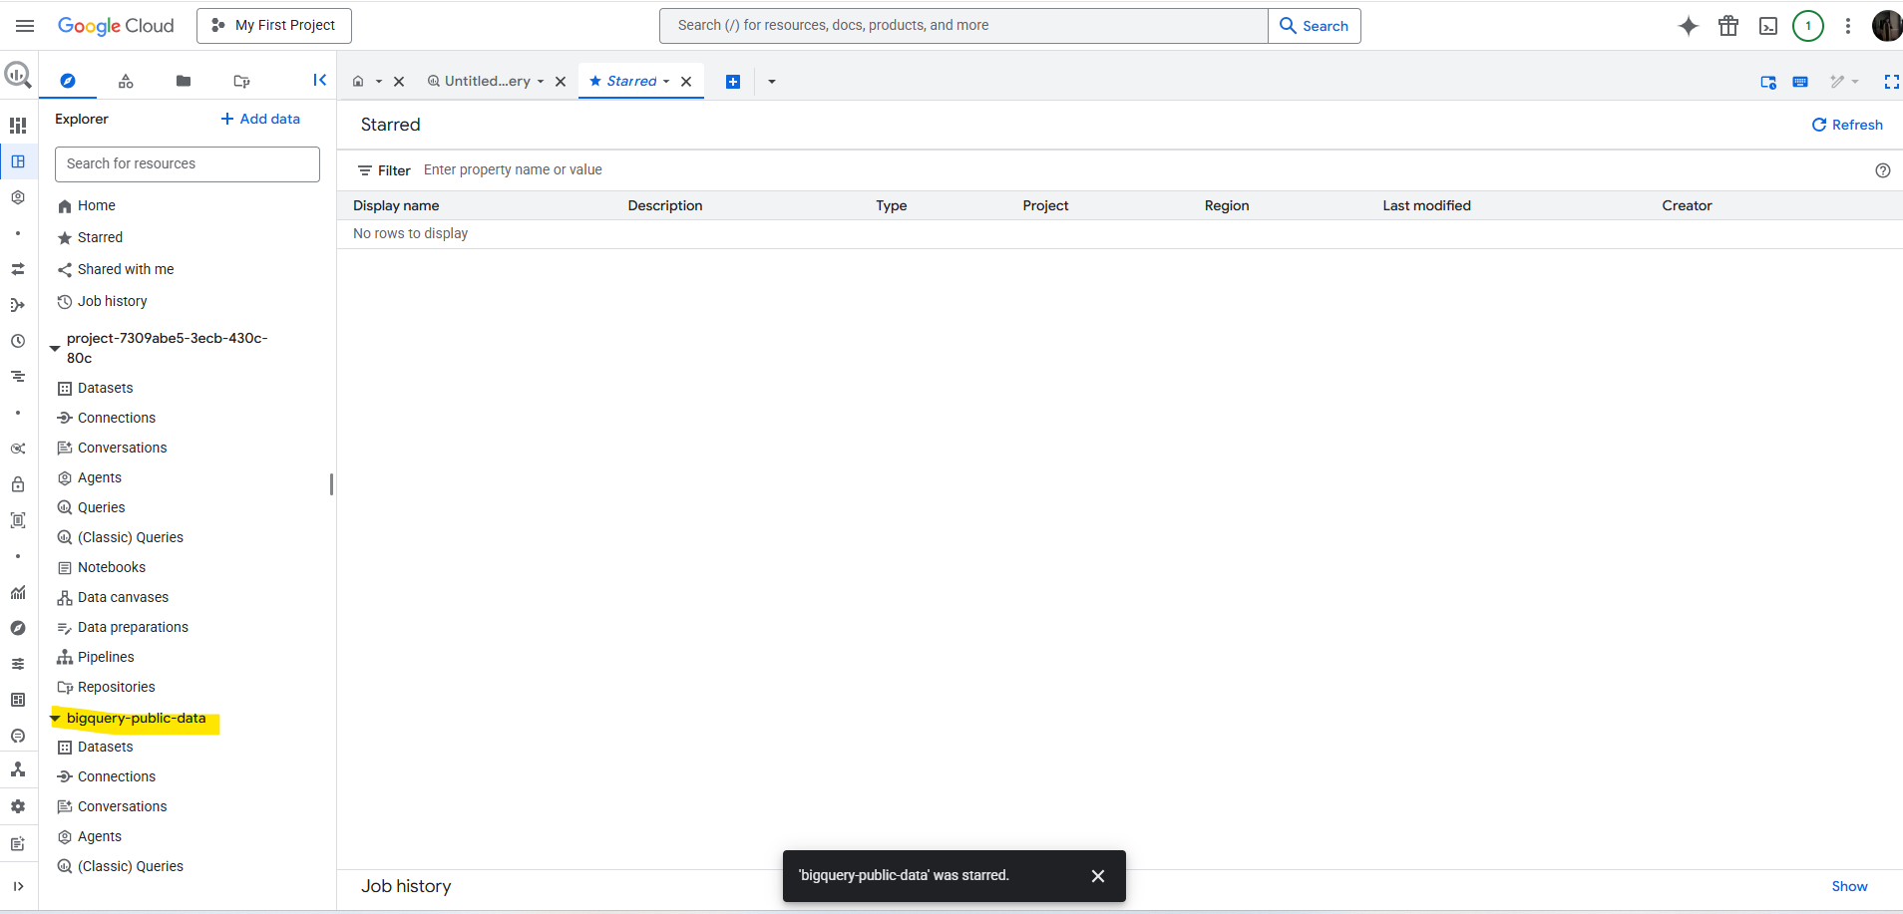
Step 3: Now, in the Explorer tab’s search bar, I typed “london_bicycles” and then clicked on “london_bicycles” to reveal the associated tables. 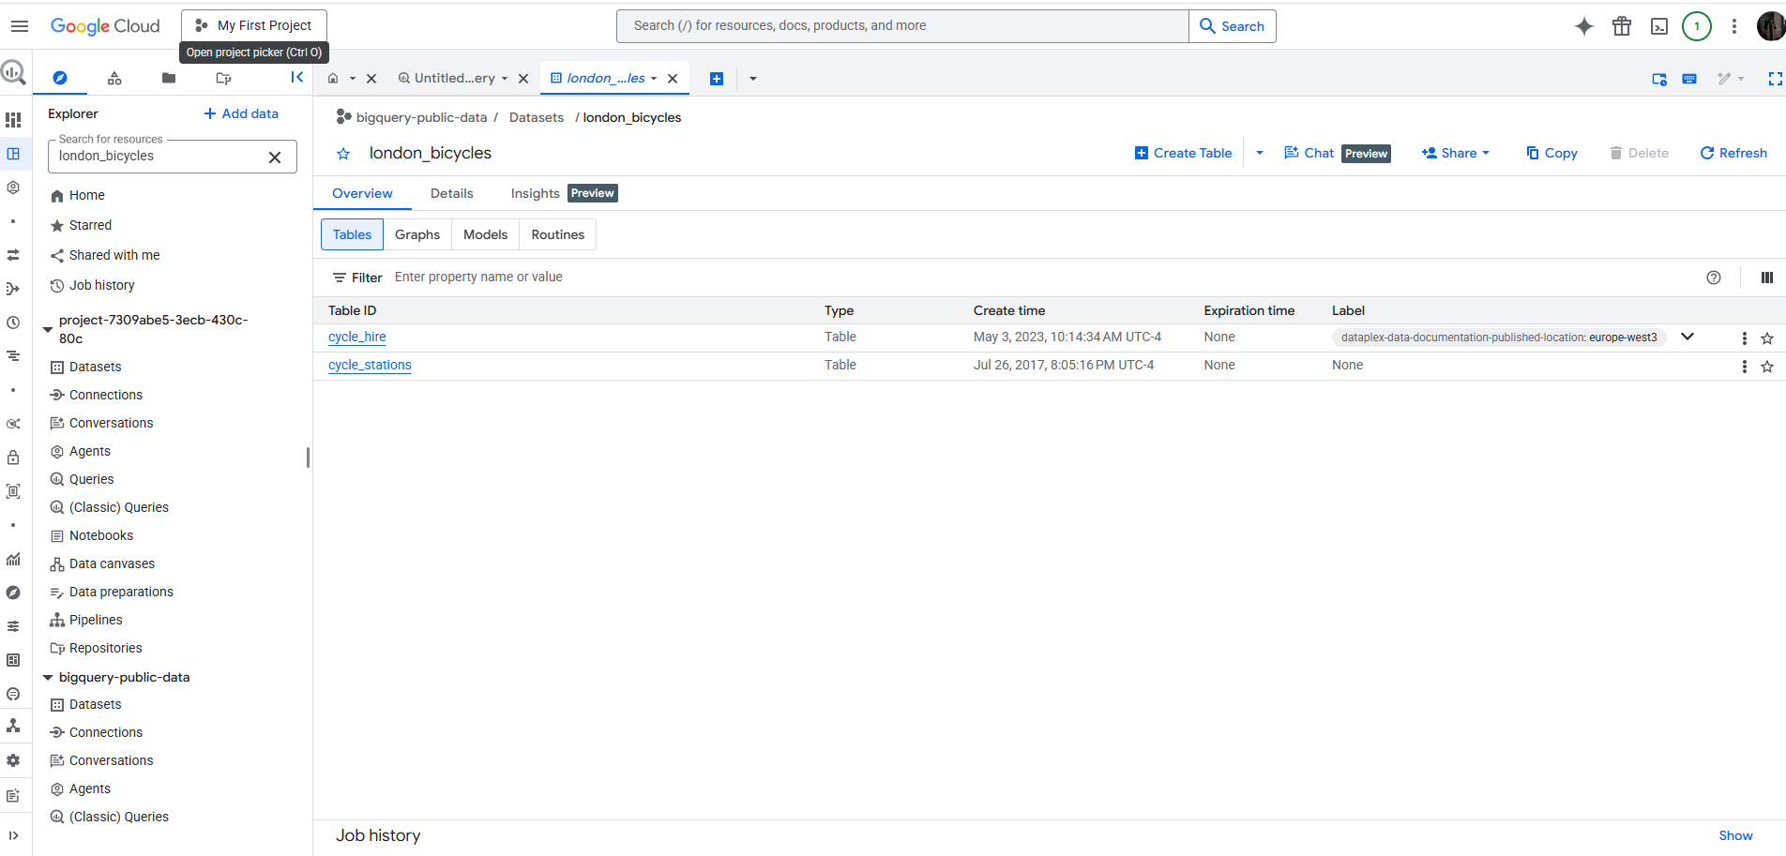
Step 4: Next, I opened the “cycle_hire” table, and clicked the preview tab. 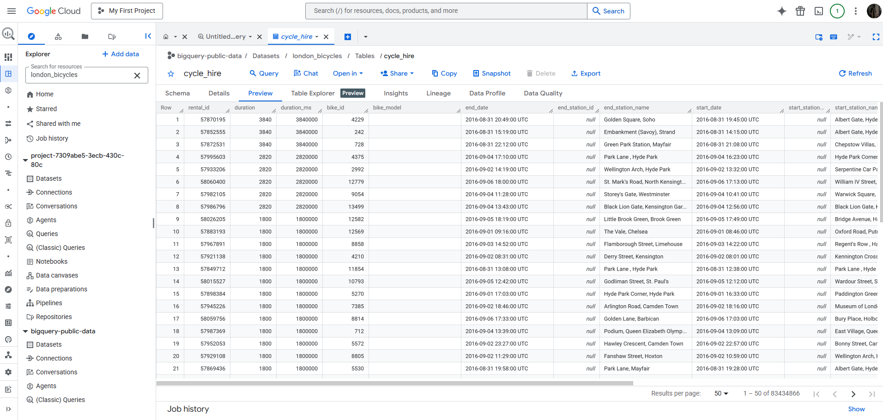
Step 5: Then, I went into Query Editor and Copied and pasted this command:
SELECT end_station_name FROM `bigquery-public-data.london_bicycles.cycle_hire`;
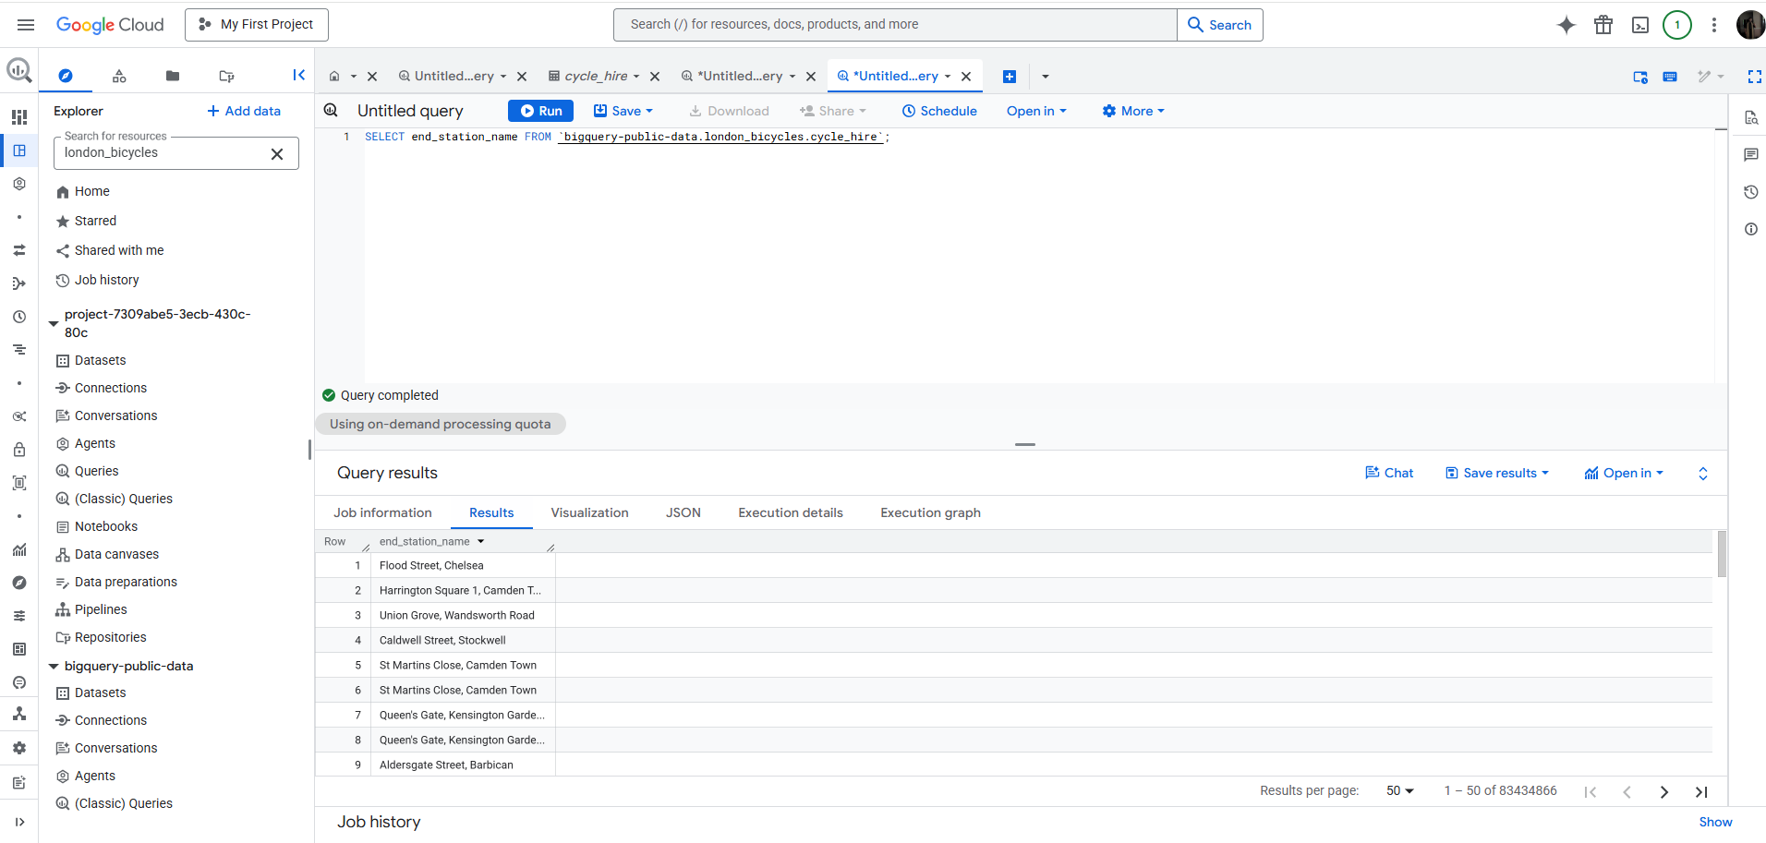

Step 6: Then, I clear the query and copy pasted this command:
SELECT * FROM `bigquery-public-data.london_bicycles.cycle_hire`WHERE duration>=1200; 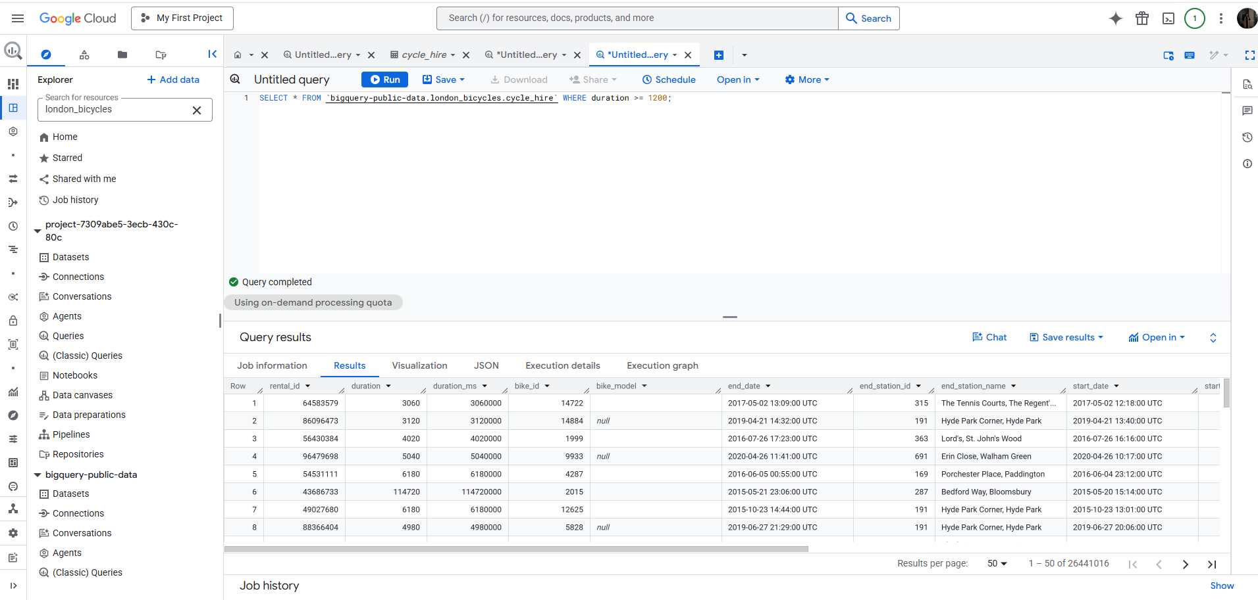
Task 2: More SQL Keywords: GROUP BY, COUNT, AS, and ORDER BY
Step 1: GROUP BY: I used the command:
SELECT start_station_name, COUNT(*) FROM `bigquery-public-
data.london_bicycles.cycle_hire` GROUP BY start_station_name; 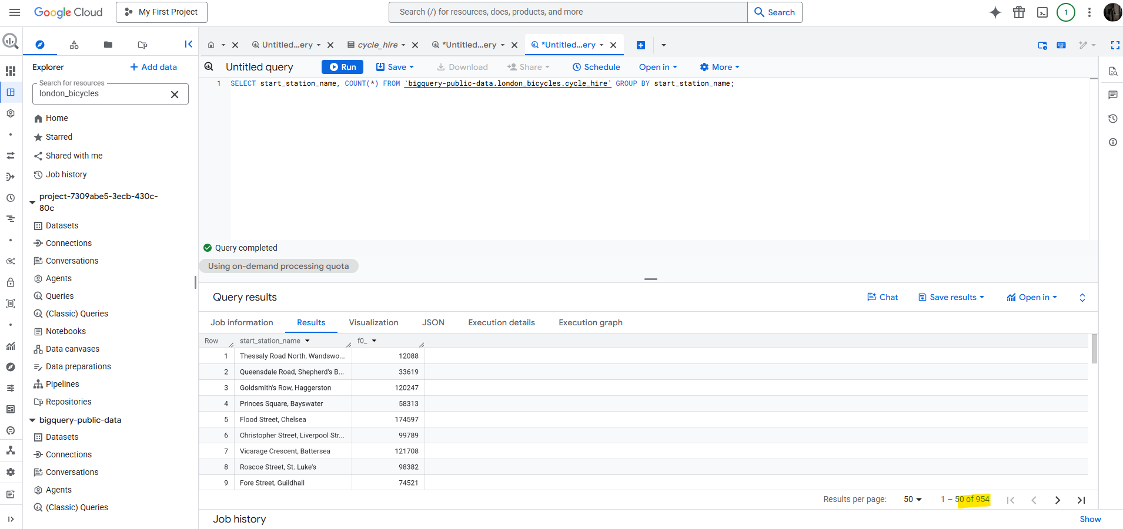
Step 2: COUNT: I used the command:
SELECT start_station_name, COUNT(*) FROM `bigquery-public-
data.london_bicycles.cycle_hire` GROUP BY start_station_name; 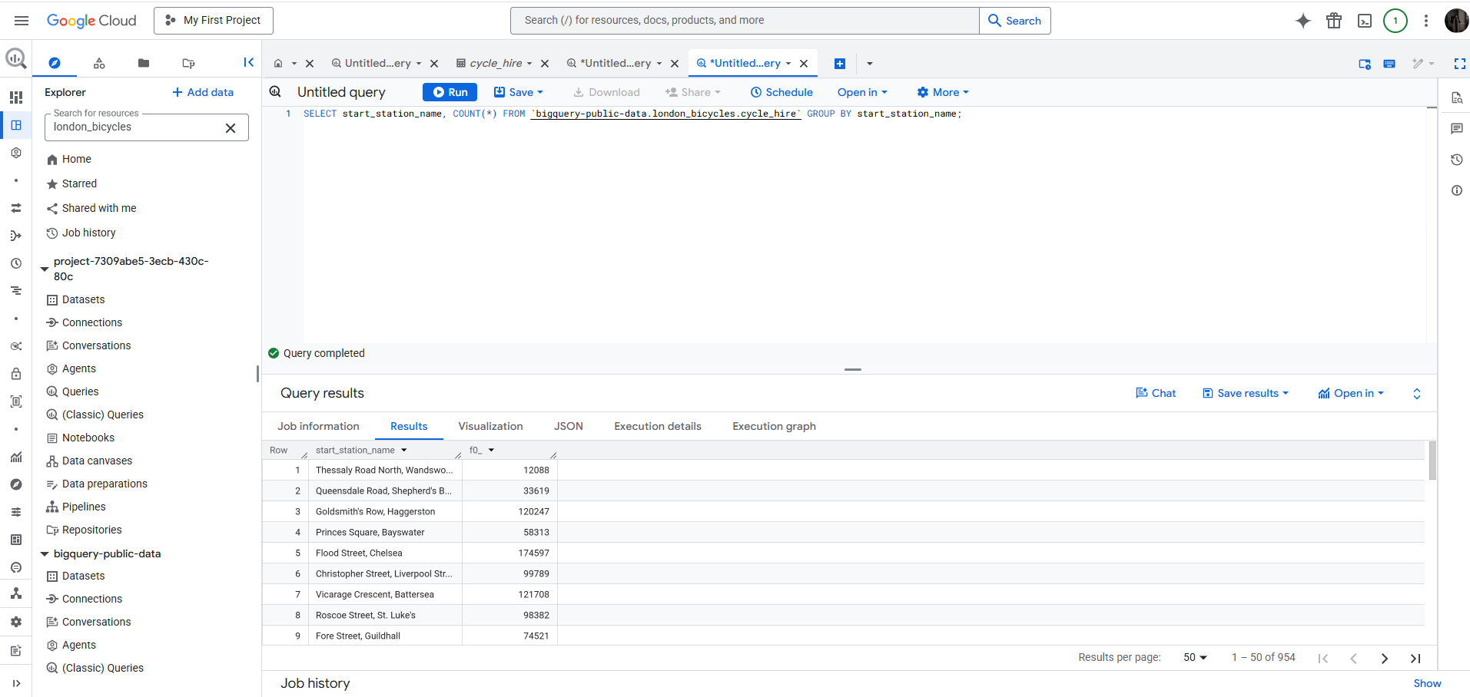

Step 3: AS – I used the command:
SELECT start_station_name, COUNT(*) AS num_starts FROM `bigquery-
public-data.london_bicycles.cycle_hire` GROUP BY start_station_name; 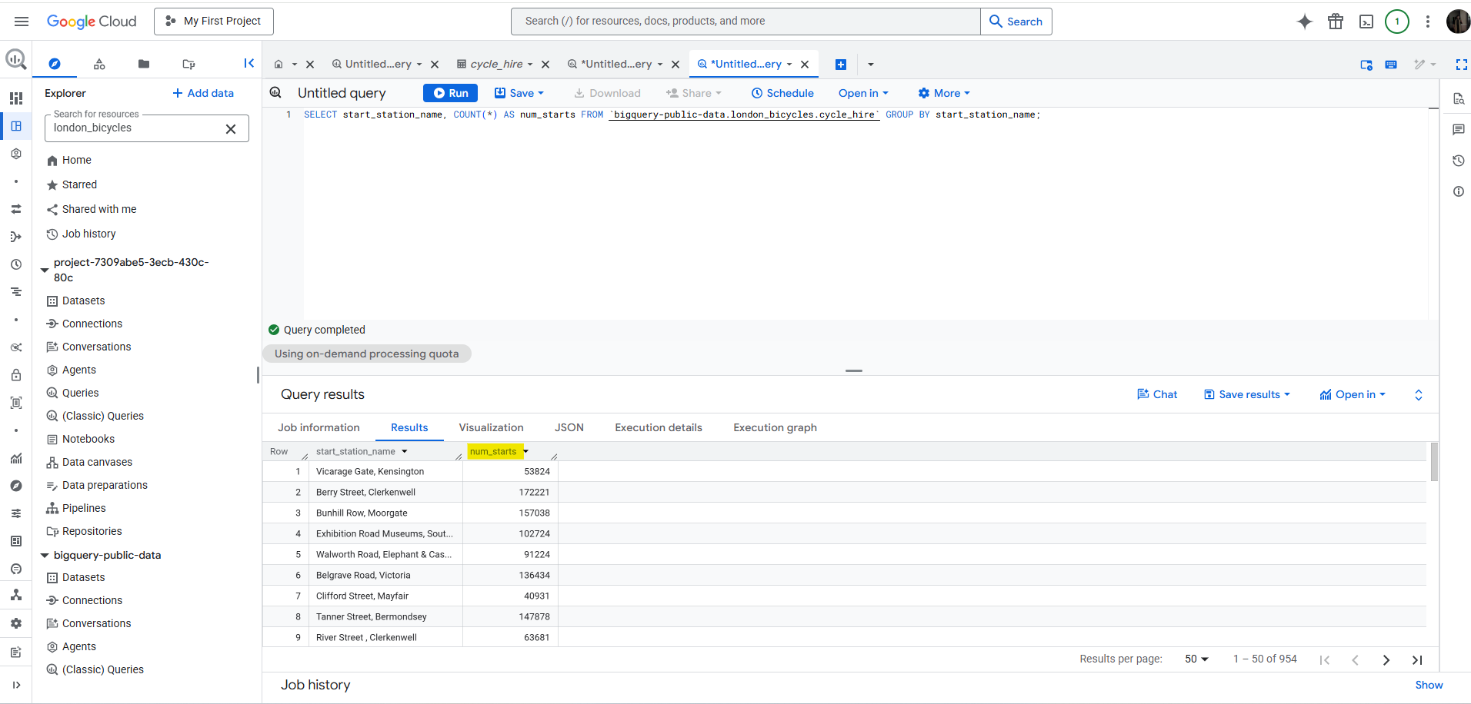
Step 4: ORDER BY – I used the command:
SELECT start_station_name, COUNT(*) AS num FROM `bigquery-public-data.london_bicycles.cycle_hire` GROUP BY start_station_name ORDER BY start_station_name; 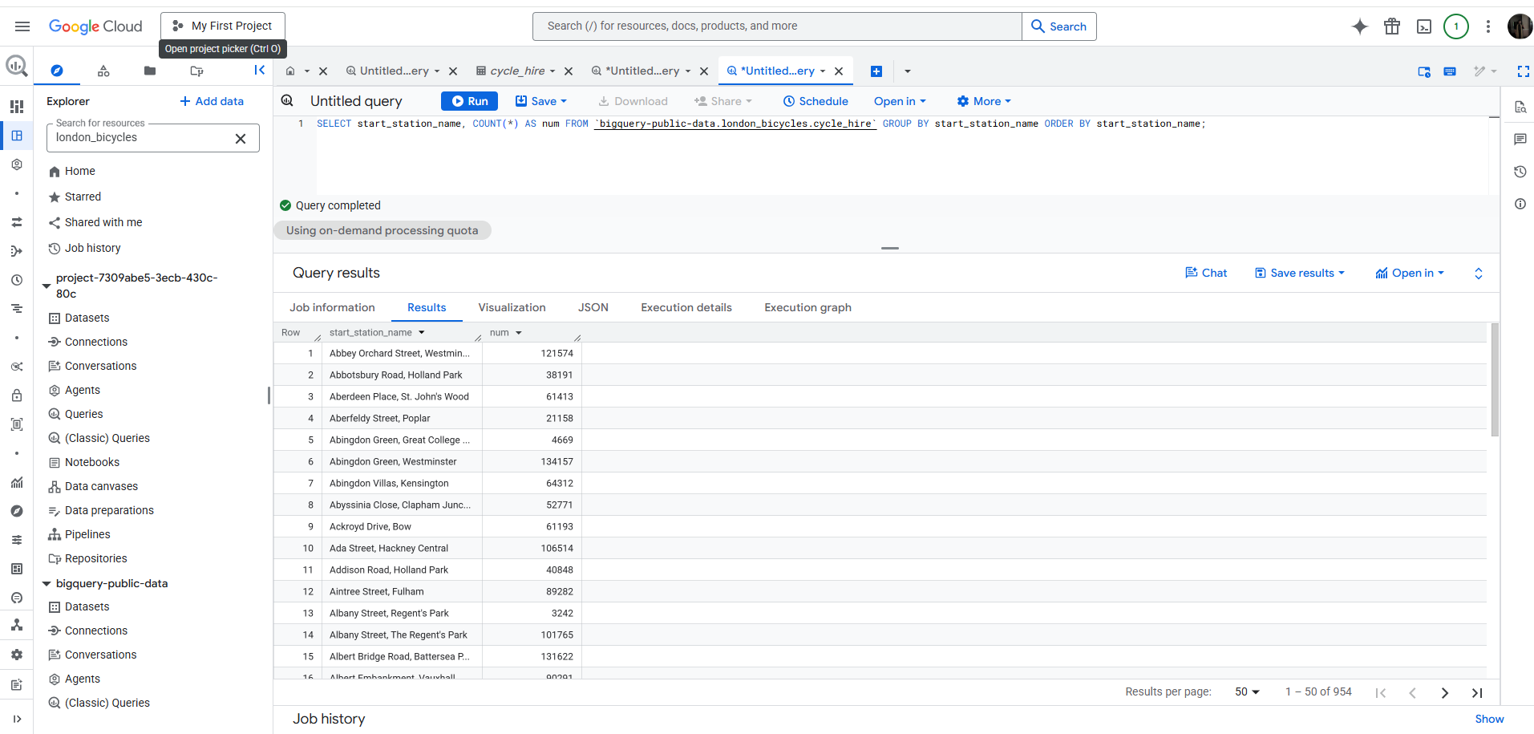
SELECT start_station_name, COUNT(*) AS num FROM `bigquery-public-data.london_bicycles.cycle_hire` GROUP BY start_station_name ORDER BY num; 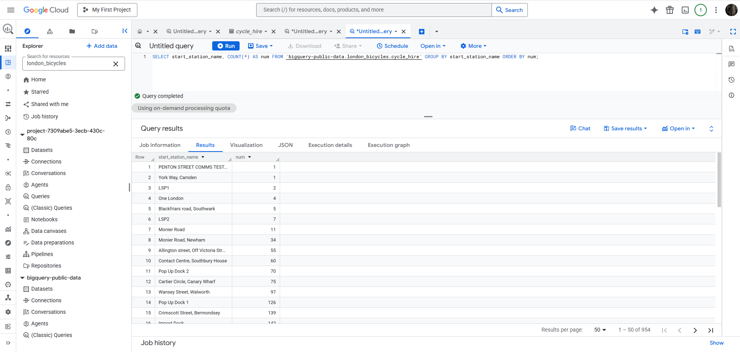
SELECT start_station_name, COUNT(*) AS num FROM `bigquery-public-data.london_bicycles.cycle_hire` GROUP BY start_station_name ORDER BY num DESC; 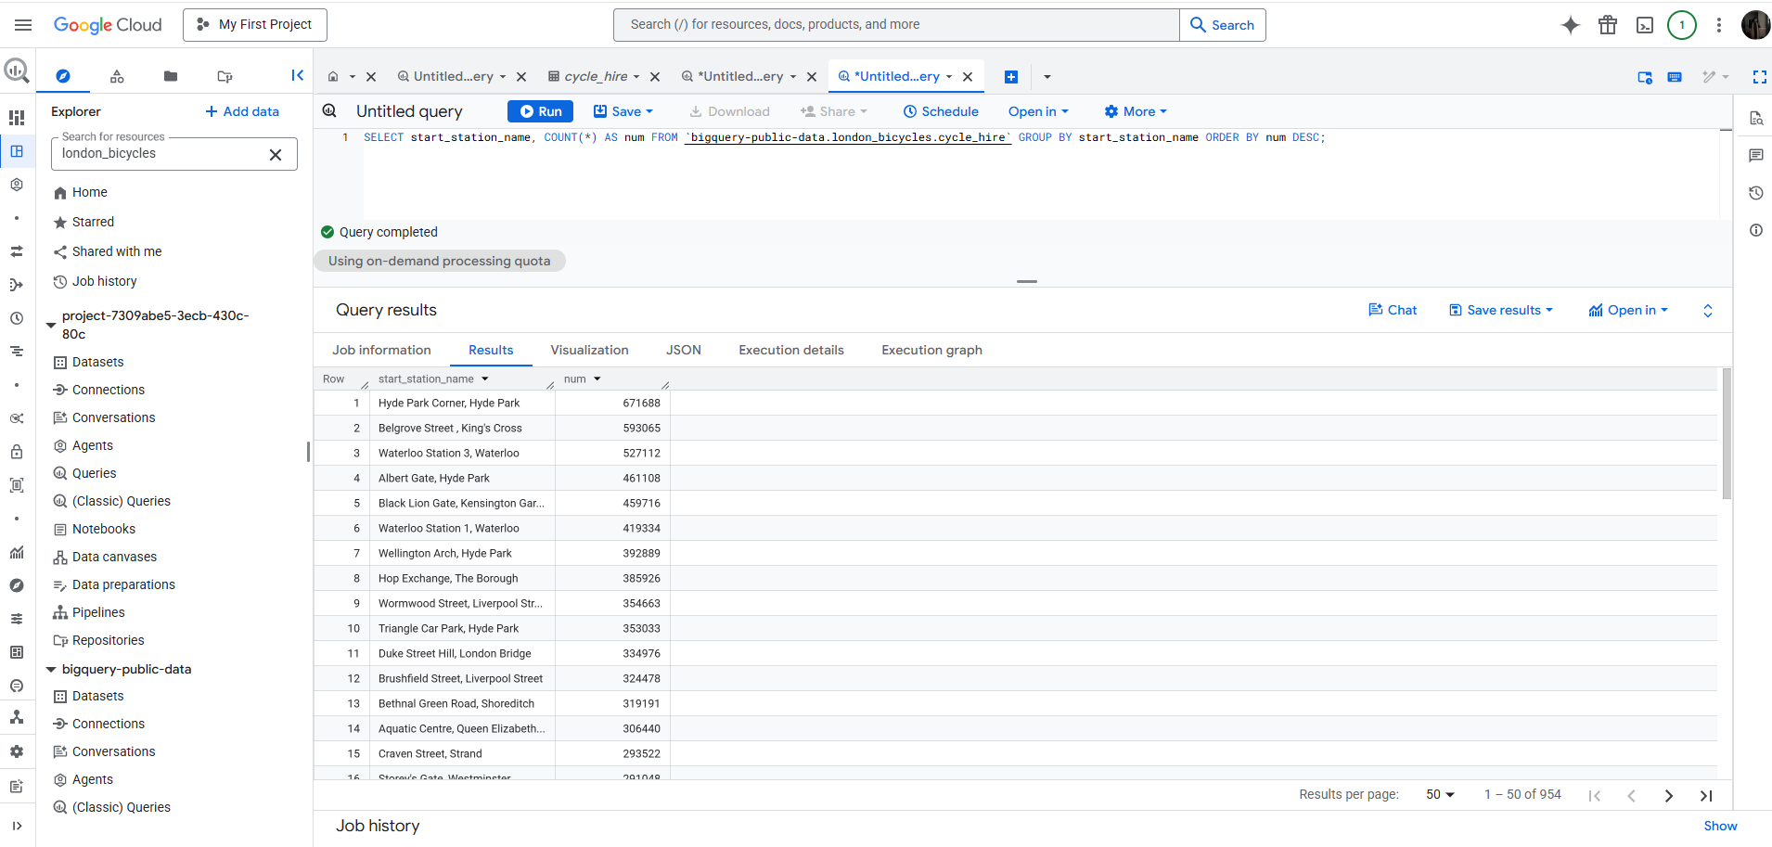

PART 2: Microsoft Azure
Step 1: On the Azure Portal menu, I selected “All services” and searched “Storage accounts”. 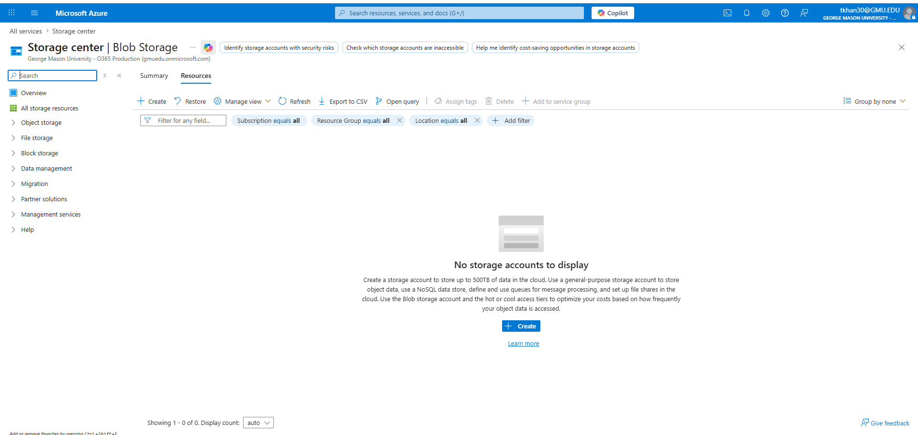
Step 2: On the storage accounts windows, I choose “Create”. Then, I chose the subscription and resource group. Then, I entered the name of the storage account as “ lab8storage123”. I kept the default region. For the performance, I chose as “Standard”. 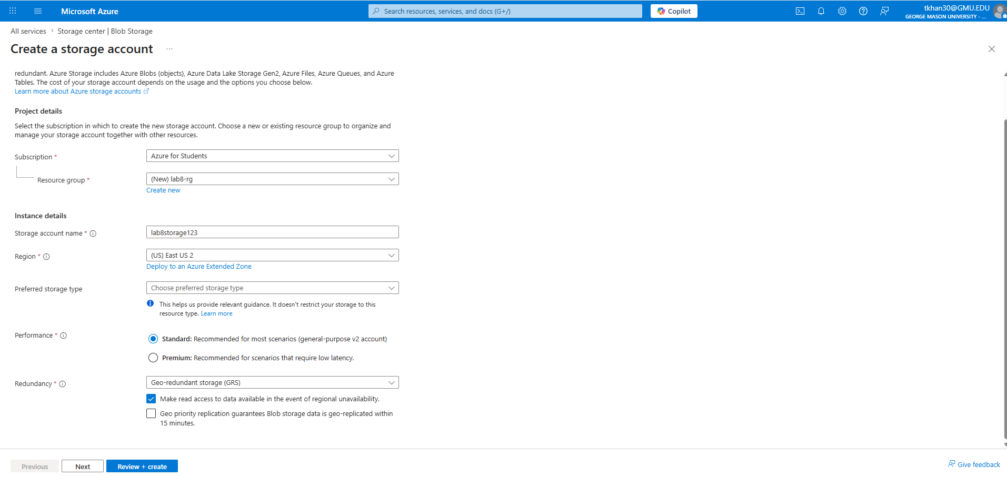
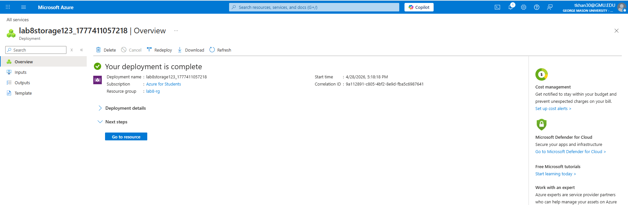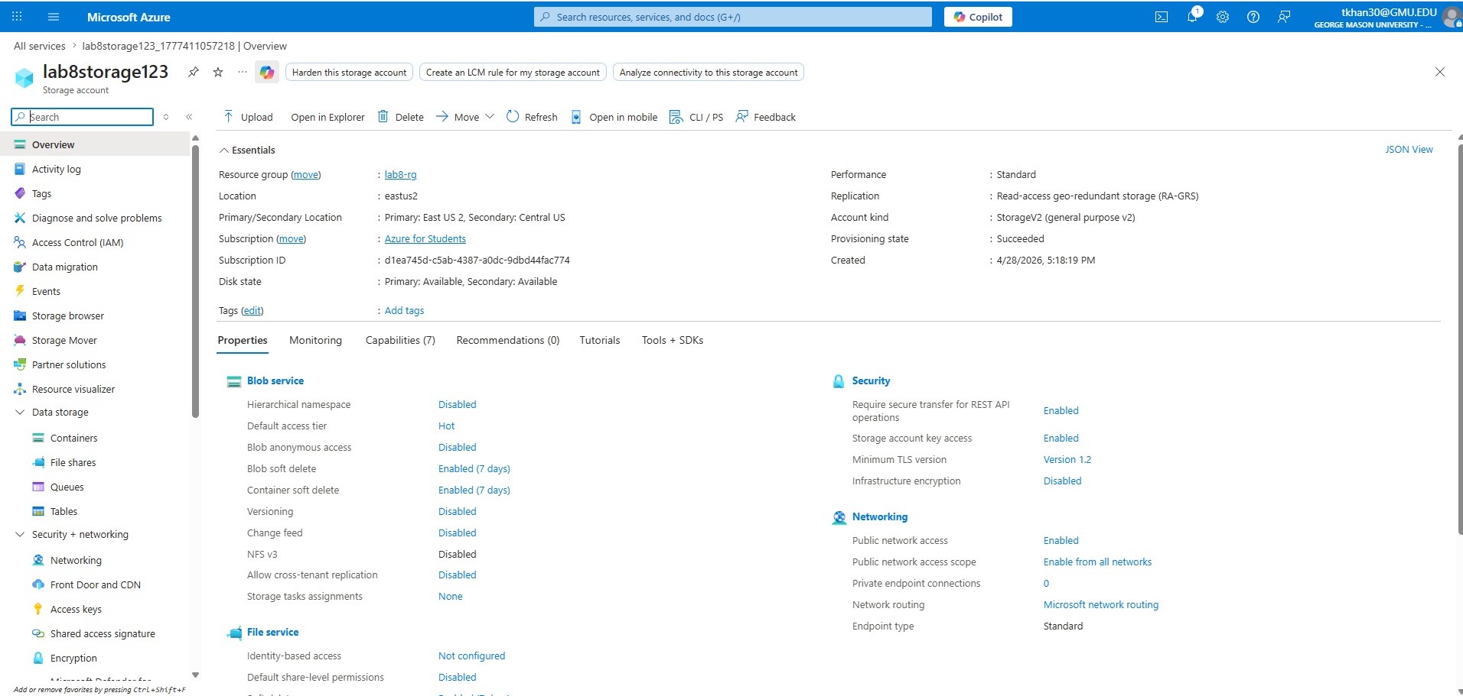

Step 3: Deleted the Storage Account